



**SM6P07NI Digital Media Project**

**20% Report**

**2023-24 Autumn**

**Student Name:** Kapil Adhikari

**London Met ID: 22068805**

**College ID:** NP01MM4A22014

**External Supervisor:** Samir Maharjan

**Internal Supervisor** Shruti Shrestha

**Assignment Due Date: Wednesday, May7,2025**

**Assignment Submission Date: Wednesday, May7,2025**

**Word Count: 2674**

*I confirm that I understand my coursework needs to be submitted online via Google Classroom under the relevant module page before the deadline in order for my assignment to be accepted and marked. I am fully aware that late submissions will be treated as non-submission and a mark of zero will be awarded.*

**Project File Links:**

|  |  |
| --- | --- |
| **YouTube Link:** | Keep Unlisted YouTube URL of your Project Here |
| **One Drive Link:** | Keep Google Drive URL of your Project Here with Anyone in Organization can View Option Enabled |

Abstract

This project involved the creation of a professional advertisement for Dulla, a premium Nepali leather brand, as part of a college digital media assignment. The documentation provides a comprehensive overview of the entire production process, from initial planning to final execution. It begins with the pre-production phase, detailing concept development, scriptwriting, location scouting, and client consultations to ensure alignment with Dulla's brand identity. The production section covers the filming process, where models showcased Dulla's leather shoes and bags in various urban lifestyle settings to highlight their versatility and elegance. Post-production activities included video editing, colour grading using DaVinci Resolve, and logo animation in After Effects to achieve a polished and professional finish. The final output was refined based on audience feedback, resulting in a compelling commercial that effectively communicates Dulla's craftsmanship and contemporary appeal. The report also includes visual examples, workflow breakdowns, and key insights to illustrate the technical and creative aspects of the project.

KapilAdikari_22068805_Report.docx

 Islington College,Nepal

Document Details

Submission ID trn:oid:::3618:94677820

25 Pages

2,683 Words

15,873 Characters

Submission Date

May 7, 2025, 10:12 AM GMT+5:45

Download Date

May 7, 2025, 10:14 AM GMT+5:45

File Name KapilAdikari_22068805_Report.docx

File Size

18.6 KB

10% Overall Similarity

The combined total of all matches, including overlapping sources, for each database.

Match Groups

 12 Not Cited or Quoted 10%

Matches with neither in-text citation nor quotation marks

0 Missing Quotations 0%



Matches that are still very similar to source material

0 Missing Citation 0%



Matches that have quotation marks, but no in-text citation

0 Cited and Quoted 0%



Matches with in-text citation present, but no quotation marks

Top Sources

|  |  |
| --- | --- |
| 2% | Internet sources |
| 0% | Publications |
| 10% | Submitted works (Student Papers) |

Integrity Flags

0 Integrity Flags for Review

Our system's algorithms look deeply at a document for any inconsistencies that would set it apart from a normal submission. If we notice something strange, we flag it for you to review.

A Flag is not necessarily an indicator of a problem. However, we'd recommend you focus your attention there for further review.

Match Groups

 12 Not Cited or Quoted 10%

Matches with neither in-text citation nor quotation marks

0 Missing Quotations 0%



Matches that are still very similar to source material

0 Missing Citation 0%



Matches that have quotation marks, but no in-text citation

0 Cited and Quoted 0%



Matches with in-text citation present, but no quotation marks

Top Sources

|  |  |
| --- | --- |
| 2% | Internet sources |
| 0% | Publications |
| 10% | Submitted works (Student Papers) |

Top Sources

The sources with the highest number of matches within the submission. Overlapping sources will not be displayed.

1

Submitted works

University of Canterbury on 2013-11-08 3%

2

Internet

[www.coursehero.com](https://www.coursehero.com/file/233156218/sujan-docx/) 2%

3

Submitted works

East Riding College on 2023-03-09 2%

4

Submitted works

The University of Wolverhampton on 2023-05-15 <1%

5

Submitted works

South Bank University on 2009-04-19 <1%

6

Submitted works

Anglia Ruskin University on 2024-07-05 <1%

7

Submitted works

Asia Pacific University College of Technology and Innovation (UCTI) on 2024-11-26 <1%

8

Submitted works

Oxford Brookes University on 2021-04-12 <1%

9

Submitted works

islingtoncollege on 2025-01-24 <1%

10

Submitted works

Tresham College of Further and Higher Education on 2022-05-20 <1%

11

Submitted works

University of Portsmouth on 2015-04-17

**Contents**

1 Introduction 1

1.1 Topic 1

1.2 Area of Research 1

2 Aims of Project 2

3 Target Audience 3

4 Product Research 4

5 Technologies Employed 5

6 Project Plan 6

7 Production Phases 7

8 Resources 8

9 User Testing & Findings 9

10 Conclusion 10

11 References 11

12 Bibliography 12

13 Appendix 13

**Table of contents**

Figure 1 Showing user Persona 3

Figure 2 Image of Survey 1 15

Figure 3 Image of Survey 2 15

Figure 4 Figure 3 Image of Survey 3 16

Figure 5 Figure 3 Image of Survey 4 16

Figure 6 Image of Survey 5 17

Figure 7 Image of Survey 6 17

Figure 8 Image of survey 7 18

Figure 9 Image of Survey 8 18

Figure 10 Image of Survey 9 19

Figure 11 Image of Log Sheet 1 20

Figure 12 Image of log sheet 2 21

Figure 13 Image of log sheet 3 22

Figure 14 Image of log sheet 4 23

Figure 15 Image of log sheet 5 24

Figure 16 Image of log sheet 7 25

Figure 17 Image of log sheet 7 26

Figure 18 Image of log sheet 8 27

Figure 19 Image of log sheet 9 28

Figure 20 Image of log sheet 10 29

Figure 21 Image of log sheet 11 30

Figure 22 Image of log sheet 12 31

Figure 23 Image of log sheet 13 32

Figure 24 Image of log sheet 14 33

Figure 25 Image of log sheet 15 34

Figure 26 Image of log sheet 16 35

Figure 27 Managing Project in Trello 1 36

Figure 28 Managing Project in Trello 2 36

Figure 29 Managing Project in Trello 3 37

Figure 30 Managing Project in Trello 4 37

# Introduction

## Topic

This project is about making a compelling commercial advertisement for Dulla, a premium high quality Nepali leather brand. After conducting a lot of desk research and brainstorming, the team built an idea that they resonated well with the thought and audience of the brand. It was a process that was nothing short of what you would find in any kind of industry season (pre, shoot, and post), and turned-out excellent quality.

Consulting with supervisors, the client, and advertising professionals ensured that feedback kept the campaign at a professional level. Having a planned feedback loop enabled iterative improvements as each stage was performed. This project also lent itself to collaboration, time management, and creative development beyond the technical skills previously mentioned. In the end, it was a very gratifying and personally meaningful experience for the team.

## Area of Research

The Dulla leather commercial was crafted through meticulous research and strategic planning. Market analysis identified key consumer insights and competitive positioning within luxury leather goods. The creative approach balanced emotional storytelling with technical precision - showcasing handmade craftsmanship through cinematic lighting, slow-motion shots, and macro details. Premium visuals were enhanced by professional colour grading and immersive sound design. Every element, from the refined colour palette to the curated music selection, worked together to elevate Dulla's heritage brand into the luxury space while maintaining authentic Nepali craftsmanship at its core.

# 2. Aims of the Project

The Dulla commercial project aims to defend the fashion and lifestyle market position of the existing brand by combining an impressive visual and an emotional story. Its key purposes include:

**Brand Awareness & Expansion into New Markets**

The commercial will introduce top-tier leather goods (bags, shoes, wallets) to a style-savvy audience that's all about desirability.

**Bridging Tradition & Modernity**

By incorporating Nepali craftsmanship with modern aesthetics, the project will help establish Dulla as a competitive brand that caters to the expectation of the modern consumer while respecting local artisanship.

**Building a Familiarity with Customers**

With cinematic storytelling, exquisite styling, and high production value, the commercial will create an emotional bond with viewers, creating brand loyalty and love for luxurious, Nepali products.

# 3. Target Audience

**Target Audience**

**Age: 18–40 years**

(Working professionals, college goers and stylish young men who look for stylish yet durable everyday wear.)

**Gender: All genders**

**Lifestyle**: (Dulla’s leather items are functional wear for all occasion through both casual and formal, promoting confidence with versatility at its finest.)

**Location:** Mainly urban Nepa; Digital via Instagram, Tiktok & Facebook

(Bringing potential buyers together local and Nepalese artistry to the world.)

**Why This Audience**?

* Younger as well as style-oriented from 18–40 years are more willing to invest in accessories.
* The gender neutrality is a broad market appeal.

# User Persona

Figure 1 Showing user Persona

**User Persona:**

Name: Sandesh Bhandari

Age: 26

Gender: Male

Profession: Branch Manager of Banking

Income Per Month: NPR 80,000 – 1,00,000

Location: Kathmandu, Nepal

Education: MBA in Finance

Marital Status: Engaged.

Transportation: Owns personal vehicle (Hyundai Creta)

Current Residence: A 2BHK flat on rent in Lazimpat

Shopping Style: High-to-mid-range

**Lifestyle & Behavior:**

* Works six days a week, dresses up in business formal dress every day.
* Prefer wearing quality leather footwear and also use a leather laptop bag (in professional appearance).
* Check out fashion accessories online but goes to local Nepali brands for shoes and bags if you can get the quality.
* Enjoys raiding parties, networking functions, and family reunions.
* Attracted by good design, status, and style that will last, not only in terms of quality but timelessness itself.
* Supports Nepali brands earning the international standards.
* .Goes on occasional weekend drives with his wife and prefers practical, stylish gear when travelling.

**Needs & Goals:**

I want to get ready neat and gentleman at work and social occasions.

Search for leather goods that are durable, classic, and suitable for both the office and personal.

* Wants to invest in local craftsmanship but wants a quality assurance of the product.
* Usually prefers clean and minimalist but elegant looking designs which stand out.

**Pain Points:**

* Sick and tired of all the cheap, mass-produced stuff that breaks down so fast.
* Struggles to find quality leather products in Nepal, without importing.
* Works full time, so has little time to shop in person.

**Why Dulla Appeals to Him**:

* Dulla designs high-end, handmade leather goods to complement his work and personal life.
* Items are fashionable but not showy, just right for a sophisticated effortless appearance.
* The brand identity resonates with his principle of supporting local quality with global standards.
* The focus is on urban Nepali whose preference is mostly on fashion-oriented so this may be a good option, and digital platforms will help to attract international buyers.

# 4. Product Research

Dulla Leather commercial was inspired by high fashion brands such as Kinnoti and implemented the minimalist visual aesthetics, smooth camera movement, and close-up shots highlighted craftsmanship. Cinematic lighting (low-key/high contrast), non-verbal storytelling through models and styling, post-production techniques (slow motion + warm color grading) Chilly aches employed a huge status of aerial textures, atmosphere, and stylish music, each of which reaffirmed a luxury appeal through sound design. The first teaser was based on a digital-first strategy, which made sure to be optimized for social media (Instagram, TikTok). This particular strategy establishes Dulla as a high-end lifestyle brand, instead of just a leather goods brand.

# 5. Technology employed

The Dulla leather commercial was primarily developed using:

**DaVinci Resolve.**

* For Editing, Color grading and Final Logo Animation.
* Only used it for the first animation of the logo, finished everything else on DaVinci Adobe After Effects

**Cinematic Methods**

* Gliding shot (dolly, slider, gimbal) & simple lighting.
* Sound: Minimalist ambient sounds and refined music.

**Digital optimization**

* social-friendly deliverables (1:1, 9:16) for IG & TikTok
* Workflow: Most of the post-production was done on DaVinci Resolve. We had high-end workflow and fast process.

# 5. Project Plan

**Revised Production Timeline and Adjustments**

**Initial Plan vs Final Execution**

**Reason for Delay:**

* The main model became unavailable last minute forcing the planned February and march shoot to be cancelled and rescheduled.

**New Timeline Adjustments**

**Pre-Production Extended (Sept-Early April)**

Additional time was used to

* Re-secure a suitable replacement model
* Reconfirm locations and crew availability
* Refine storyboards based on the new models look

**Production shifted to April**

* Shoot condensed into 5 days (Originally 2 week) to meet deadlines
* No reshoots strict adherence to shots lists ensured efficiency

**Post-production Accelerated late April**

* **Editing and colour grading completed in 1 week (**vs 4 week initially)
* **Changes made**
* Simplified transition for faster rendering
* Adjusted colour grading to match new lightning condition

|  |  |  |  |
| --- | --- | --- | --- |
| **Phase** | **Old timeline** | **New Timeline** | **Reason** |
| Production | Feb-march | Late April | Model unavailability |
| **Postproduction** | April-May | Late April (1 week) | Compressed scheduled |
| Reshoots | 2 days planned | None | Tight Timeline |

**Comparison between New and old Gant chart**

Figure 2 New Gantt Chart

Figure 3 Old Gantt Chart

# 6. Production Phase

**Stages of Production (Summarized) Shooting the Dulla Leather Commercial**

**Pre-Production Phase**

**Phase 1**: Establish concept, logistics plan, and draft for filming.

**Key Steps:**

* **Concept Research: Taking** inspiration from high fashion brands (e.g. Kinnoti) for clean premium imagery.
* **Script & Storyboard:** Non-verbal storytelling based on close-up shots of the product and showcasing model’s sophistication.
* **Casting:** Select a model (Rahul Rawal) who closely resembles the unique bold yet elegant brand personality of Dulla.
* **Location Scouting**: Taaj Palace (chosen) and minimalistic interior spaces.

**Production Phase**

**Goal:**Film spot on point

**Key Steps:**

* **Call sheet:** Call sheet table with crew member (Roles), Time and Equipment
* **Shoot:**

Featured leather items (boots, bags) in lifestyle context.

Employed stable lighting and motion of the camera.

Versatility on the set for impromptu artistic enhancements

* **Collaboration:** Working with classmates to troubleshooting.

**Post-Production Phase**

**TASK:** Turn raw footage into a designed final cut.

**Key Steps:**

* **Editing in (DaVinci Resolve):**

A strict sequence of clips per storyboard; tight cut on pacing.

Additional background music for emotions

* **Color Grading**:

Enhance white levels for natural colors.

Enhanced shadows/midtones for a modern, luxurious look.

* **Output:**Final Render with social media friendly formats.

# 7. Resources

**Tools for producing the Dulla Leather commercial:** Hardware & Software

**Production Hardware (Filming Gear)**

**Primary Tools (As Planned):**

* SONY FX3 (4K Cinema Line Camera for more natural images)
* How do the stabilization: Gimbal (for smooth shots tracking)
* Stabilization: Tripod (instead static shots and stability)
* Type: LED panels/soft boxes (to control the lighting for a more premium feel)
* LCD Lilliput (framing & focus check on-set) Monitor.
* Extra Tools (On the Fly)
* Reflectors/Diffusers: Modified natural light during shoots outdoors.
* Batteries and Storage for everything Extra: More SD cards & power backups because shoot days are longer.

**Post-Production Hardware**

**Primary Tool:**

* Laptop**:** Acer Nitro 5 – (Editing/ Rendering- 12th Gen Intel Core i5, 12 CPUs)

Limitations & Adaptations:

* Rendering times**:** Slow because of high-res footage; used proxies with optimization.

**Software Tools**

Core Software (in accordance with plan):

* Edit & Color: DaVinci Resolve (timeline assembly, cuts, and color correction)
* Motion Graphics**:** Adobe After Effects (very little text animations/transitions).

Other Software (Unplanned)

* Media Management Shotput Pro (to backup/offload footage on-set)
* Audio: Used non song that matches our dulla commercial theme

Research & Testing Tools

**Pre-Production:**

* Mood Board: Pinterest & Adobe Spark Material References to Kinnoti Aesthetic
* Location scouting: Google maps/street view (initial examination before to physical visits)

**On-Set Testing:**

Exposure Test:

* light meter was used to balance exposure.
* Camera Tests: Recorded sample clips to see how skin tone/leather looks under different lighting.

Post-Production Testing:

* Export tests: dozens of exported versions (H.265-H.264) to test on the respective platform.

# 8. User Testing and Findings

The video was then tested for compatibility across devices to ensure perfect playback across various screens and resolutions. Working to keep a certain visual consistency across the board, aspect ratio integrity, and to achieve a smooth playing speed on each platform.

**Device and Display Setting**

**A. Smartphone**

**Screen Sizes:** 6” to 6.7 (common Flagship ranges).

**Aspect Ratio Tasted:**

* + **16:9** (Standard, e.g., older Samsung/LG phones)
  + **18:9** (Taller displays, e.g., Google Pixels)
  + **20:9** (Ultra-tall, e.g., Samsung Galaxy)

**Findings:**

* + There were no cropping or letterboxing problems; the adaptive scaling was right.
  + Even with small screens the text/logo clarity not compromised.

**B. Tablets**

* + Screen Sizes: 7" (Amazon Fire, for example) to 12.9" (iPad Pro).
  + Aspect Ratios Tested:
  + 4:3 (e.g., older iPads).
  + 16:10 (like Samsung Galaxy Tab)

**Findings:**

* Slight letterboxing on 4:3 devices but no missing content.
* Colors on high-resolution panels stayed vivid.

**C. Laptops & Desktops**

**Resolutions Tested:**

* Full HD compatible with devices of most monitors (1920 x 1080)
* 2560x1440 (QHD) – Top-tier Displays.
* 3440x1440 (21:9 Ultrawide) – For a cinematic experience

**Findings:**

* No seams or distortion on the ultrawide
* Playback in 4K was clear and smooth (on systems with RTX 3060).
* D. TVs

**Resolutions Tested:**

* Smart TVs (Samsung, LG) – 4K UHD (3840x2160)
* 1080p – Older LED/LCD TVs.

**Findings:**

* On compatible TVs, leather textures had boosted contrast.
* YouTube/OTT Platforms No buffer problems
* Encoding & Performance Tests
* Good= (smaller file sizes) H.264 (MP4)'s H.265 (HEVC)

**User Feedback & Iterations**

A focus group (10) assessed the advertisement on:

**Visual Appeal:**

* 9/10 described its minimalism and beauty shots of the product.
* Another user indicated that the lighting of the café scene should be brighter.

**Brand Recall:**

* 100% remember dulla after logo animation.

**Loading Times:**

* YouTube unlisted link no buffering 4G/Wi-Fi tested.

**Post-Testing Adjustments:**

* Brightened midtones in the café scene for better visibility.
* The logo animation was shortened by 0.5s for a more immediate impact.

# 9. Conclusion

This commercial project of Dulla Leather Shoes is a successful one that has purposefully attracted people grabbing the brand substance and lifestyle. It covered workflow planning in pre-production to execution; with concept, storyboarding, video shoots; which all played in bringing the shoes to the forefront in an urban professional aesthetic. The editing and color grading was done using DaVinci Resolve and some minor animated Dulla logo was done in Adobe After Effects. Extensive testing on different devices and resolutions ensured smooth playback and user feedback resulted in finer tuning for maximum effect. This results in a seamless, professionally produced commercial that fits Dulla’s brand identity, by balancing technical process with story building during postproduction which stands out to their target demographic. The secret to the project being able to deliver on both its creative, as well as technical objectives, while adhering to such a tight timeline, was detailed planning, thorough execution, and flexibility in creating television commercial content to high-end advertising standards.

# 10. References

# 11. Bibliography

# Appendix

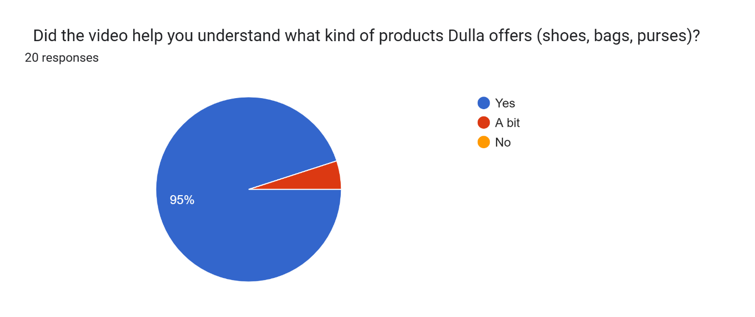

Figure 4 Image of Survey 1

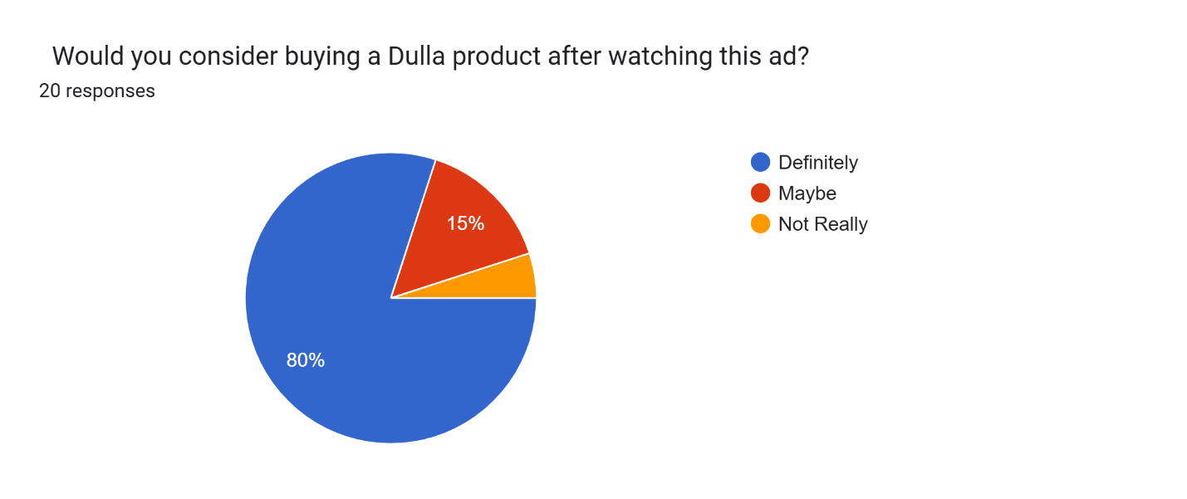

Figure 5 Image of Survey 2

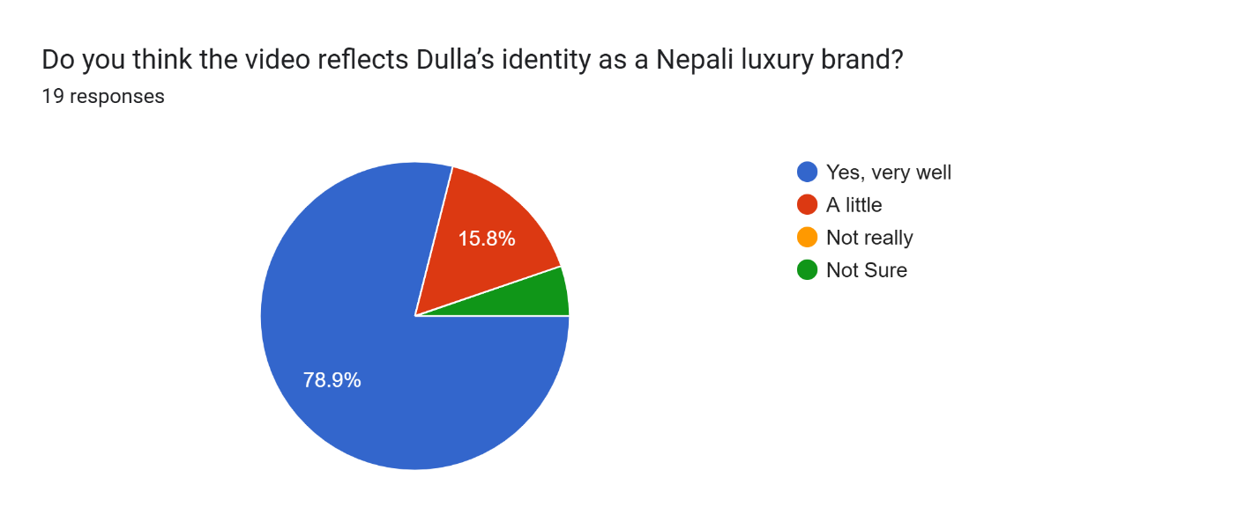

Figure 6 Figure 3 Image of Survey 3



Figure 7 Figure 3 Image of Survey 4

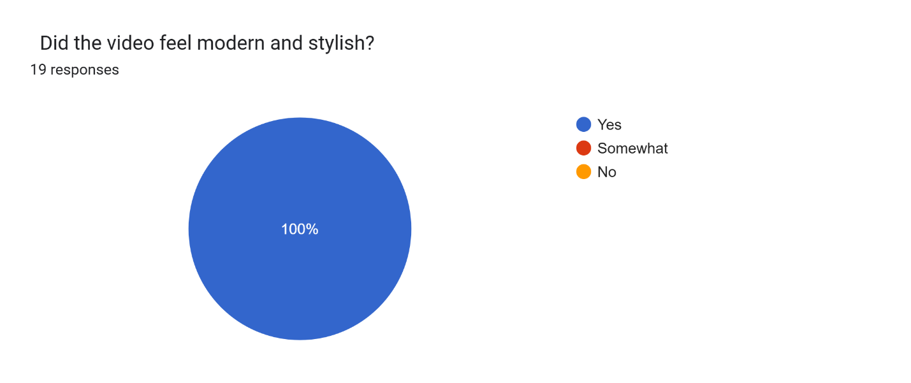

Figure 8 Image of Survey 5

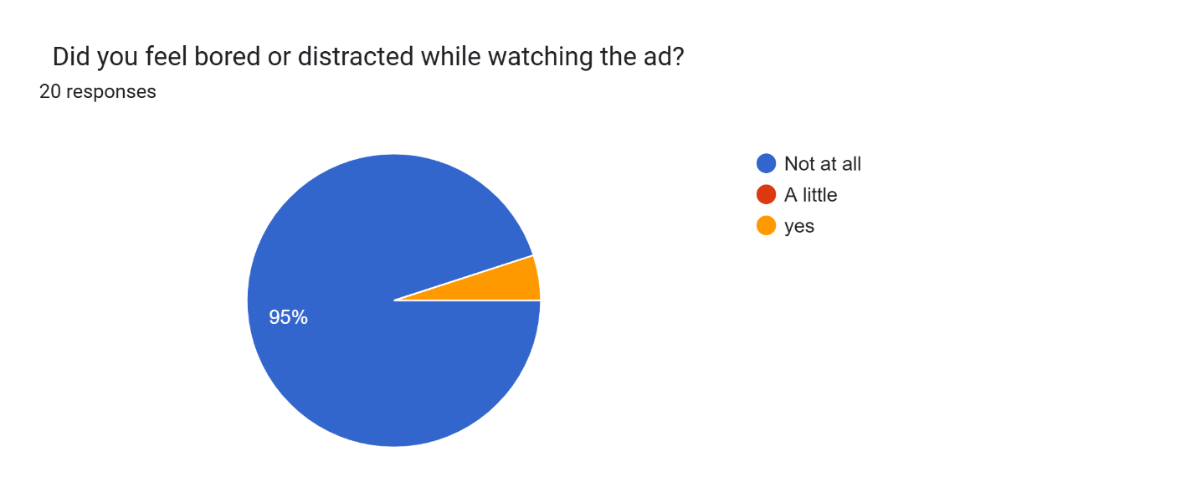

Figure 9 Image of Survey 6

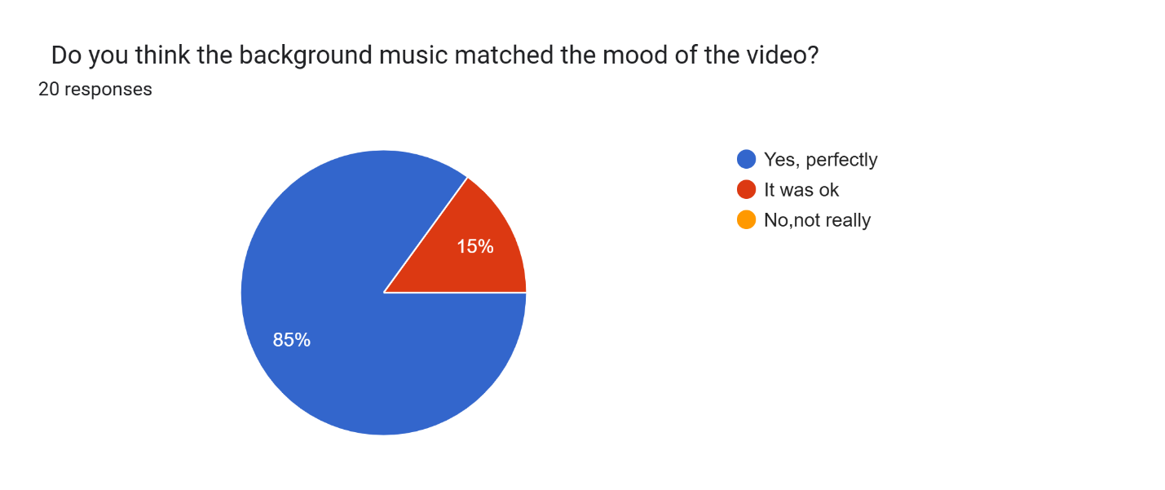

Figure 10 Image of survey 7

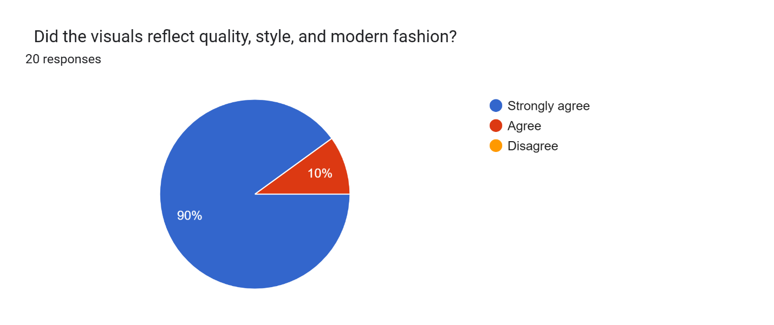

Figure 11 Image of Survey 8

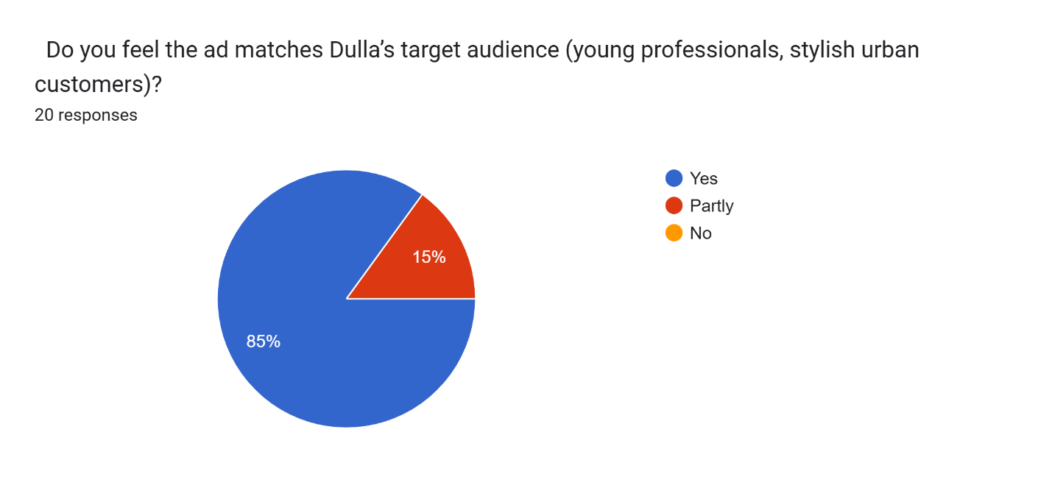

Figure 12 Image of Survey 9

Figure 13 Image of Log Sheet 1

Figure 14 Image of log sheet 2

Figure 15 Image of log sheet 3

Figure 16 Image of log sheet 4

Figure 17 Image of log sheet 5

Figure 18 Image of log sheet 7

Figure 19 Image of log sheet 7

Figure 20 Image of log sheet 8

Figure 21 Image of log sheet 9

Figure 22 Image of log sheet 10

Figure 23 Image of log sheet 11

Figure 24 Image of log sheet 12

Figure 25 Image of log sheet 13

Figure 26 Image of log sheet 14

Figure 27 Image of log sheet 15

Figure 28 Image of log sheet 16

Figure 29 Managing Project in Trello 1

Figure 30 Managing Project in Trello 2

Figure 31 Managing Project in Trello 3

Figure 32 Managing Project in Trello 4